Ideation Phase
Empathize & Discover

Date | 30 September 2026
Team Leader  Team Members | - Varsha  S.Deepika,R.Lavanya
Project Name | AI Blog Nest API
Maximum Marks | 4 Marks

Empathy Map Canvas:
An empathy map is a simple, easy-to-digest visual that captures knowledge about a user’s behaviours and attitudes.

It is a useful tool to helps teams better understand their users.
Creating an effective solution requires understanding the true problem and the person who is experiencing it. The exercise of creating the map helps participants consider things from the user’s perspective along with his or her goals and challenges.
Example:


Reference: https://www.mural.co/templates/empathy-map-canvas

Example: AI Blog Nest API
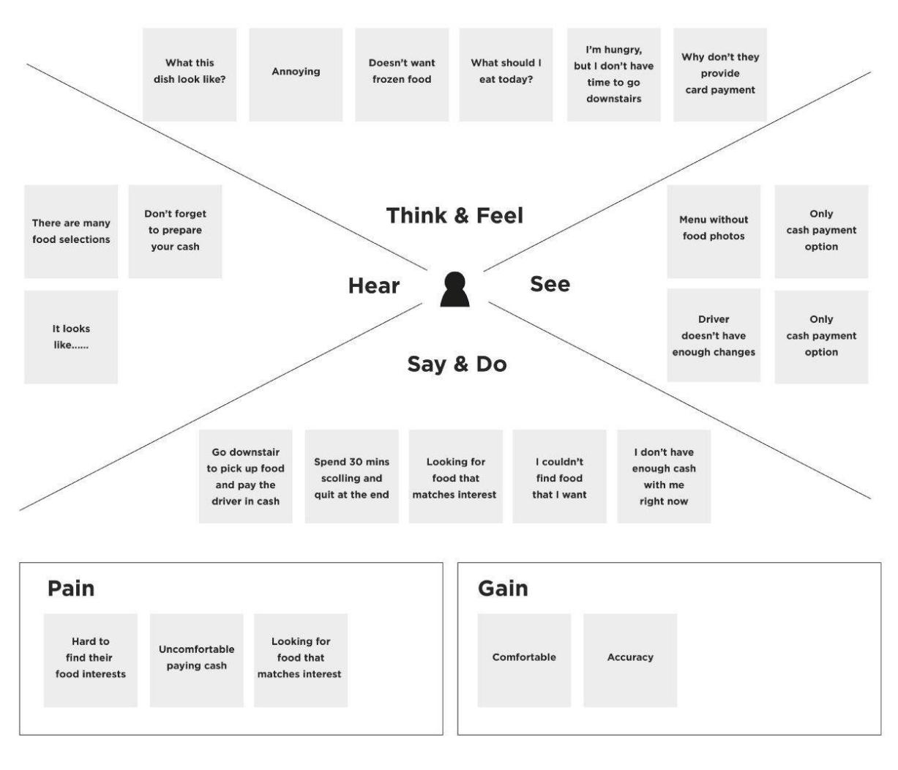

Empathy Map – AI Blog Nest API
College: C.T.T.E. College for Women
Team Leader: P. Priyadharshini
Team Members: U.S. Sadhana, R.A. Yuvashree, A. Samrin Fathima

THINK & FEEL
Wants faster content creation, reliable blog management, secure access, and concise summaries. Feels concerned about time, content quality, and security.
SEE
Sees large amounts of blog content, repeated manual writing tasks, comments requiring moderation, and the need for organized categories and tags.
HEAR
Hears requests for fresh content, readable summaries, quick publishing, secure administration, and better content discoverability.
SAY & DO
Creates or manages blog posts, adds tags/categories, reviews comments, requests AI-generated content, and uses summaries for quick understanding.
PAINS
Manual writing is time-consuming; organizing content can be difficult; comment moderation requires effort; unsafe input can create security risks; long articles take time to summarize.
GAINS
AI-assisted blog generation, automatic summarization, CRUD management, categorization, comment moderation, role-based access, and input sanitization improve efficiency and security.
Team ID: SWTID-2026-3388

